**15B11CI212 – Theoretical Foundations of Computer Science**

**Tutorial 4**

**Relations (Posets and Hasse Diagram)**

Q1. solve remaining questions of Tutorial 3.

Q2

  set of positive integers divisors of 12

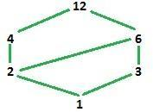

Q3. List the ordered pairs in the relations on {1, 2, 3} corresponding to these matrices (where the rows and columns correspond to the integers listed in increasing order).

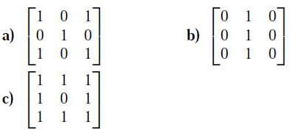

Solution: a) Since the (1,l)th entry is a 1, (1,1) is in the relation. Since (1,2)th entry is a 0, (1,2) is not in the relation. Continuing in this manner, we see that the relation contains (1, 1), (1, 3), (2, 2), (3, 1), and (3, 3).

b) (1,2). (2,2), and (3,2) c) (1,1), (1.2), (1,3), (2,1), (2,3), (3,1), (3,2), and (3,3)

Q4. list the ordered pairs in the relations represented by the directed graph

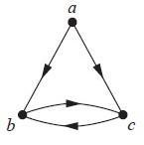

We list all the pairs (x, y) for which there is an edge from x to y in the directed graph: {(a, b), (a, c), (b, c), (c, b)}.

Q5. Which of these relations on {0, 1, 2, 3} are equivalence relations? Determine the properties of an equivalence relation that the others lack.

a) {(0, 0), (1, 1), (2, 2), (3, 3)}

b) {(0, 0), (0, 2), (2, 0), (2, 2), (2, 3), (3, 2), (3, 3)}

c) {(0, 0), (1, 1), (1, 2), (2, 1), (2, 2), (3, 3)}

d) {(0, 0), (1, 1), (1, 3), (2, 2), (2, 3), (3, 1), (3, 2), (3, 3)}

e) {(0, 0), (0, 1), (0, 2), (1, 0), (1, 1), (1, 2), (2, 0), (2, 2), (3, 3)}

Solution:

In each case we need to check for reflexivity, symmetry, and transitivity.

1. This is an equivalence relation; it is easily seen to have all three properties. The equivalence classes all have just one element.
2. This relation is not reflexive since the pair (1, 1) is missing. It is also not transitive, since the pairs (0, 2) and (2, 3) are there, but not (0, 3).
3. This is an equivalence relation. The elements 1 and 2 are in the same equivalence class; 0 and 3 are each in their own equivalence class.
4. This relation is reflexive and symmetric, but it is not transitive. The pairs (1, 3) and (3, 2) are present, but not (1, 2).
5. This relation would be an equivalence relation were the pair (2, 1) present. As it is, its absence makes the relation neither symmetric nor transitive.